ONEWAY CRT BY Temp
/STATISTICS DESCRIPTIVES HOMOGENEITY WELCH
/PLOT MEANS
/MISSING ANALYSIS.

Oneway

Notes
Output Created |  | 05-May-2019 23:51:09
Comments
Input | Active Dataset | DataSet0
Input | Filter | <none>
Input | Weight | <none>
Input | Split File | <none>
Input | N of Rows in Working Data File | 30
Missing Value Handling | Definition of Missing | User-defined missing values are treated as missing.
Missing Value Handling | Cases Used | Statistics for each analysis are based on cases with no missing data for any variable in the analysis.
Syntax |  | ONEWAY CRT BY Temp  /STATISTICS DESCRIPTIVES HOMOGENEITY WELCH  /PLOT MEANS  /MISSING ANALYSIS.
Resources | Processor Time | 00 00:00:00.140
Resources | Elapsed Time | 00 00:00:00.157

[DataSet0]

Descriptives
 | N | Mean | Std. Deviation | Std. Error
Between 22°C-18°C | 9 | 8.6444 | 3.08185 | 1.02728
Between 24°C-26°C | 6 | 9.5833 | 3.95495 | 1.61460
In between 24°C and 22°C | 13 | 8.4923 | 3.48388 | .96626
Less than 18°C | 2 | 6.7000 | 2.68701 | 1.90000
Total | 30 | 8.6367 | 3.32291 | .60668

Descriptives
 | 95% Confidence Interval for Mean |  | Minimum | Maximum
 | Lower Bound | Upper Bound | Minimum | Maximum
Between 22°C-18°C | 6.2755 | 11.0134 | 4.40 | 12.40
Between 24°C-26°C | 5.4329 | 13.7338 | 4.50 | 14.00
In between 24°C and 22°C | 6.3870 | 10.5976 | 3.20 | 13.60
Less than 18°C | -17.4418 | 30.8418 | 4.80 | 8.60
Total | 7.3959 | 9.8775 | 3.20 | 14.00

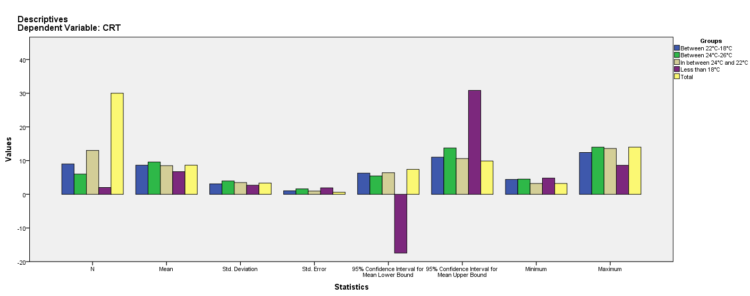

Test of Homogeneity of Variances
CRT
Levene Statistic | df1 | df2 | Sig.
.425 | 3 | 26 | .736

ANOVA
CRT
 | Sum of Squares | df | Mean Square | F | Sig.
Between Groups | 13.150 | 3 | 4.383 | .371 | .774
Within Groups | 307.060 | 26 | 11.810
Total | 320.210 | 29

Robust Tests of Equality of Means
CRT
 | Statisticª | df1 | df2 | Sig.
Welch | .357 | 3 | 4.840 | .787
a. Asymptotically F distributed.

Means Plots

